**Questions:**

1. Modify the Python and Prolog codes demonstrated above to find the grandparents of somebody.
2. Enrich the KB demonstrated above with ‘brother’, ‘sister’, ‘uncle’ and ‘aunt’ rules in Python and Prolog.

**Solution to the question no. 1:**

**The demonstrated Prolog code to find grandchildren of someone is as below:**

parent('Hasib' , 'Rakib'). parent('Rakib' , 'Sohel'). parent('Rakib' , 'Rebeka'). parent('Rashid' , 'Hasib'). grandparent(X, Z) :- parent(X, Y), parent(Y, Z).

findGc :- write(' Grandchild: '), read(X), write('Grandparent: '), grandparent(Gc, X), write(Gc), tab(5).

findGc.

**A sample input and output is as below:**

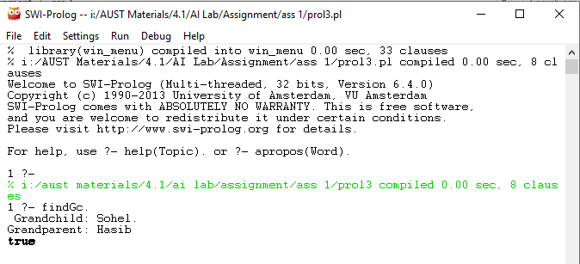

**The demonstrated Python code to find grandchildren of someone is as below:**

tupleList1=[('parent', 'Hasib', 'Rakib'),('parent', 'Rakib', 'Sohel'),('parent', 'Rakib', 'Rebeka'),('parent', 'Rashid', 'Hasib')]

# Procedure to find the grandchildren of X

X=str(input("Grandchildren:"))

print('Grandparent:', end=' ')

i=0

while(i<=3):

if ((tupleList1[i][0] == 'parent')&( tupleList1[i][2] == X)):

for j in range(4):

if ((tupleList1[j][0] == 'parent') & ( tupleList1[i][1] == tupleList1[j][2])):

print(tupleList1[j][1], end=' ')

i=i+1

**A sample input and output is as below:**

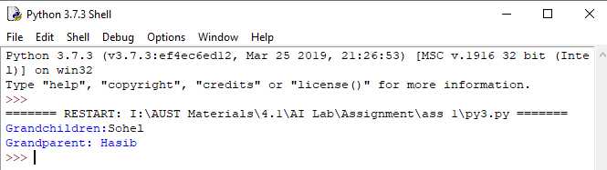

**Solution to the question no. 2:**

**The demonstrated Prolog code to find ‘brother’, ‘sister’, ‘uncle’ and ‘aunt’ of someone is as below:**

parent('Hasib' , 'Rakib'). parent('Rakib' , 'Sohel'). parent('Rakib' , 'Rebeka').

parent('Hasib','Rashid'). parent('Hasib','Salma'). grandparent(X, Z) :- parent(X, Y), parent(Y, Z).

male('Hasib'). male('Rakib'). male('Sohel'). male('Rashid').

brother(X,Y):- parent(Z,X), parent(Z,Y), male(X), not(X=Y).

sister(X,Y):- parent(Z,X), parent(Z,Y), not(male(X)), not(X=Y).

uncle(X,Y):- brother(X,Z), parent(Z,Y), male(X).

aunt(X,Y):- sister(X,Z), parent(Z,Y), not(male(X)).

**A sample input and output is as below:**

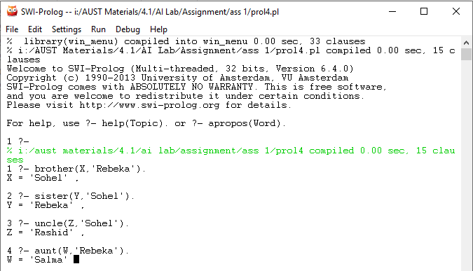

**The demonstrated Python code to find ‘brother’, ‘sister’, ‘uncle’ and ‘aunt’ of someone is as below:**

# Find the grandchildren of X

tupleList1=[('parent', 'Hasib', 'Rakib'),('parent', 'Rakib', 'Sohel'),('parent', 'Rakib', 'Rebeka'),('parent', 'Hasib', 'Rashid'),('parent', 'Hasib', 'Salma')]

maleList=['Hasib','Rakib','Sohel','Rashid']

#find brother

print('Finding Brother...')

X=str(input("Person: "))

print('Brother:', end=' ')

i=0

while(i<=4):

if ((tupleList1[i][0] == 'parent')&( tupleList1[i][2] == X)):

for j in range(5):

if(( tupleList1[i][1] == tupleList1[j][1]) & (tupleList1[i][2] != tupleList1[j][2])):

for k in range(4):

if(tupleList1[j][2] == maleList[k]):

print(tupleList1[j][2])

i=i+1

#find sister

print('\nFinding Sister...')

X=str(input("Person: "))

print('Sister:', end=' ')

i=0

while(i<=4):

if ((tupleList1[i][0] == 'parent')&( tupleList1[i][2] == X)):

for j in range(5):

if(( tupleList1[i][1] == tupleList1[j][1]) & (tupleList1[i][2] != tupleList1[j][2])):

isSister = True

for k in range(4):

if(tupleList1[j][2] == maleList[k]):

isSister = False

if(isSister):

print(tupleList1[j][2])

i=i+1

print('\nFinding Uncle...')

#find Uncle

X=str(input("Person: "))

print('Uncle:', end=' ')

i=0

while(i<=4):

if ((tupleList1[i][0] == 'parent')&( tupleList1[i][2] == X)):

for t in range(5):

if ((tupleList1[t][0] == 'parent')&( tupleList1[t][2] == tupleList1[i][1])):

for j in range(5):

if(( tupleList1[t][1] == tupleList1[j][1]) & (tupleList1[t][2] != tupleList1[j][2])):

for k in range(4):

if(tupleList1[j][2] == maleList[k]):

print(tupleList1[j][2])

i=i+1

print('\nFinding Aunt...')

#find Aunt

X=str(input("Person: "))

print('Aunt:', end=' ')

i=0

while(i<=4):

if ((tupleList1[i][0] == 'parent')&( tupleList1[i][2] == X)):

for t in range(5):

if ((tupleList1[t][0] == 'parent')&( tupleList1[t][2] == tupleList1[i][1])):

for j in range(5):

if(( tupleList1[t][1] == tupleList1[j][1]) & (tupleList1[t][2] != tupleList1[j][2])):

isSister = True

for k in range(4):

if(tupleList1[j][2] == maleList[k]):

isSister = False

if(isSister):

print(tupleList1[j][2])

i=i+1

**A sample input and output is as below:**

